**Abstract**

Accent effect means investigating the accents spoken by the Arab, the differences between them, and the purpose they serve which can be reflected on the grammatical and phonological effects on Quran recitations. The title of this study is **"Accent Effect on Linguistic and Grammatical Orientation According to Maki bin Abi Talib Al Qaisi's (d.437 A. H) "*Al Hidaya Fi Bulough Al Nihaya"***. This effect which serves Arabic language that was honored by Almighty God to be the language of Quran. The holy book which God preserved from any distortion or change : "We have, without doubt, sent down the Message; and We will assuredly guard it (from corruption)" Quran 15:9.

One of the reasons behind choosing this topic is responsibility towards the study of this field of language. This urges us to take the Quran as the logic in the study, investigation, purification, and revision of the rules of other levels of language.

The other reason is that the book in question is away from any philosophical and logical complications; it is marked by its easy, brief, and significant style.

Moreover, this study discusses the work of one of our greatest scholars in the field of Quran and grammar studies. He is Maki bin abi Talib Al Qeisi. Accordingly, the study consisted of an introduction, a background, three chapters, a conclusion, and a bibliography.

The background consists of two sections. The first one is a biography of Maki bin abi Talib Al Qeisi and the second section about his book **"*Al Hidaya Fi Bulough Al Nihaya"***.

The first chapter is entitled: 'The Accent Effect on Phonological Orientation ". It includes five sections. The first one is about the "hamza" (glottal stop) its stressed and unstressed utterance, the second is about short and long letter forms, while the third is about assimilation and fusion. The fourth section is about stressing and unstressing, while the fifth chapter is on adding and deleting short vowels.

The second chapter is entitled: 'The Accent Effect on Morphological Orientation ". It includes three sections. The first one discusses structural system. The second is about the patterns and formula. The third is about replacement and vowels.. The third is about singular, dual, and plural forms.

The third chapter is entitled: 'The Accent Effect on Syntactic Orientation ". It includes three sections. The first one is about nunnation, insertion and non-inflectives. The second section dealt with transitive and intransitive verbs. The third section dealt with parsing forms.

The bibliography included the sources used in writing the study. The basic source were ***"Al Hidaya"*** and ***"Mushkil I'rab Al Qura"*** by Maki Al Qeisi. There are other sources in grammar like Sibaweih's ***"Al Kitab"*** and Al Mubarid's ***"Al Muqtadhab"***. Another group of sources was specialized in the meanings in Quran and its parsing like Al Farra', Al Akhfash, and Al Zajaj's ***"Ma'ani Al Quran"*** (The Meanings of Quran) as well as books in the interpretation of the Quran like Al Tabari's ***"Jami' Al Bayan"*** and ***"Al Bahr Al Muhit"*** by Abo Hayan. It also included books in accents and languages like ***"fi Al Lahajat Al Arabia"*** (Arabic Accents) by Ibrahim Anees and ***"Al Lahajat al Arabia fi Al Qira'at Al Qurania"*** (Arabic accents in Quran Recitations) by Abda Al Rajihi and books in Quran recitations like ***"Al Sab'a fi Al Qira'at "***

(The Seven Recitations), as well as dictionaries like ***"Al Ein"*** by Al Farahidi and ***"Lisan Al Arab"*** by Ibn Mandhor.

Finally, I would like to express my gratitude to the professors of the Department of Arabic Language, especially, my supervisor, Dr. Othman Rahmaan Al Arraki , Dr. Leith As'aad Abdulhameed the Head of the department, Dr. Mohammad Abdulrasoul, Dr. Ayad Al Hamdani and to all the friends and colleagues who helped me. I also would like to thank the University of Diyala in general, and College of Education for Human Sciences in particular as well as the discussion committee who will evaluate this study and add their wise notices.

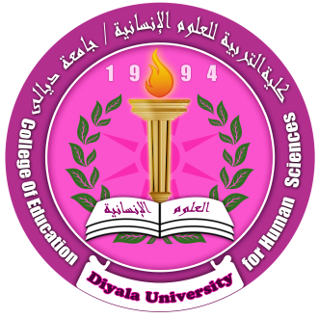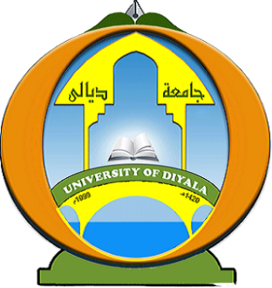**Ministry of Higher Education and**

**Scientific Research**

**University of Diyala**

**College of Education for Human Sciences**

**Department of Arabic Language**

**Accent Effect on Linguistic and Grammatical Orientation According to Maki bin Abi Talib Al Qeisi's (d.437 A. H) "*Al Hidaya ila Bulough Al Nihaya"***

**A thesis submitted to the council of College of Education for Human Sciences, University of Diyala in partial fulfillment of the requirements of the degree of Master of Arts in Arabic Language and Arts**

**By**

**Hameed Rasheed Ahmed**

**Supervised by**

**Prof. Uthman Rahmaan Hameed Al Arraqi (Ph.D.)**

**1436 A. H. 2014 A.D.**